**Assignment-1 : Creation of a simple Topology**

**Code:-**

#create a new simultor object

set ns [new Simulator]

#open the NAM trace file

set nf [open ass3.nam w]

$ns namtrace-all $nf

#open the Trace file

set nt [open ass3.tr w]

$ns trace-all $nt

#define the 'finish' procedure

proc finish {} {

#declaring ns nf as global variables

global ns nf nt

#clearing the file ns of any residual data

$ns flush-trace

#close the NAM file

close $nf

#close the Trace file

close $nt

#execute NAM file

exec nam ass3.nam &

exit 0

}

#create nodes

set n0 [$ns node]

set n1 [$ns node]

set n2 [$ns node]

set n3 [$ns node]

#creating links between nodes

$ns duplex-link $n0 $n1 10Mb 5ms SFQ

$ns duplex-link $n0 $n2 10Mb 5ms SFQ

$ns duplex-link $n0 $n3 10Mb 5ms SFQ

$ns at 10.0 "finish"

$ns run

**Output:-**

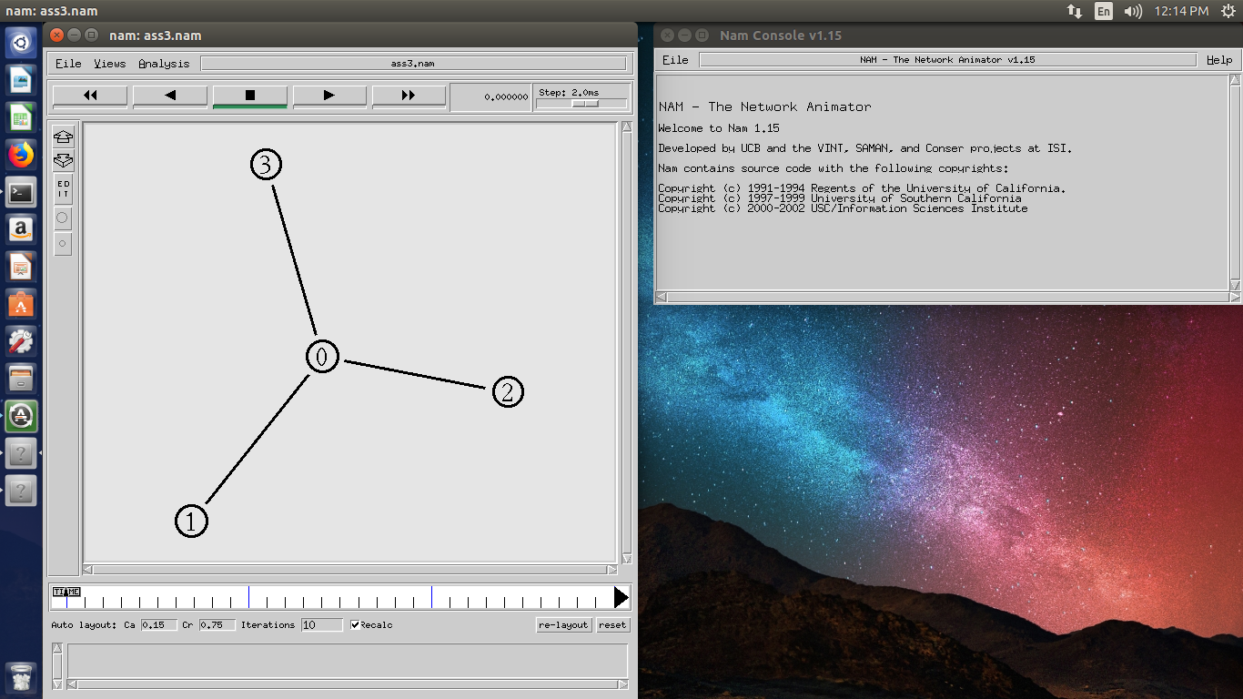

**Assignment-2 : CBR over UDP**

**Code:-**

set ns [new Simulator]

set nf [open ass7.nam w]

$ns namtrace-all $nf

set nt [open ass7.tr w]

$ns trace-all $nt

proc finish {} {

global ns nf nt

$ns flush-trace

close $nf

close $nt

exec nam ass7.nam &

exit 0

}

set n1 [$ns node]

set n2 [$ns node]

set n3 [$ns node]

set n4 [$ns node]

$ns duplex-link $n1 $n2 10Mb 5ms SFQ

$ns duplex-link $n1 $n3 20Mb 10ms SFQ

$ns duplex-link $n1 $n4 30Mb 15ms SFQ

#Setup an UDP agent

set udp [new Agent/UDP]

$ns attach-agent $n1 $udp

set null [new Agent/Null]

$ns attach-agent $n3 $null

$ns connect $udp $null

#Setup a CBR application over UDP connection

set cbr [new Application/Traffic/CBR]

$cbr attach-agent $udp

$cbr set packetsize_ 512

$cbr set rate_ 0.01Mb

$cbr set random_ false

$ns at 1.0 "$cbr start"

$ns at 3.0 "$cbrstop"

$ns at 10.0 "finish"

$ns run

**Output:-**

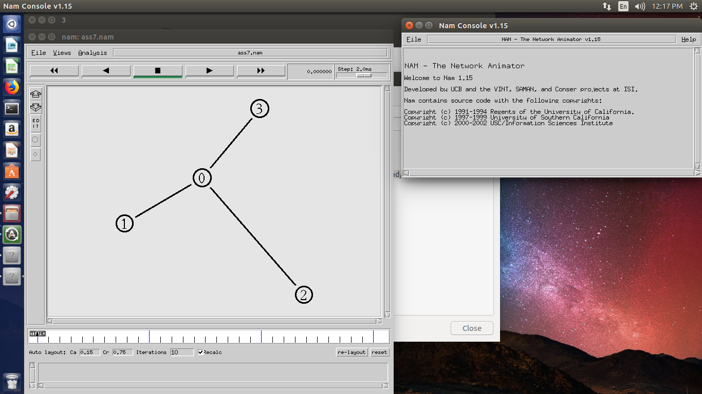

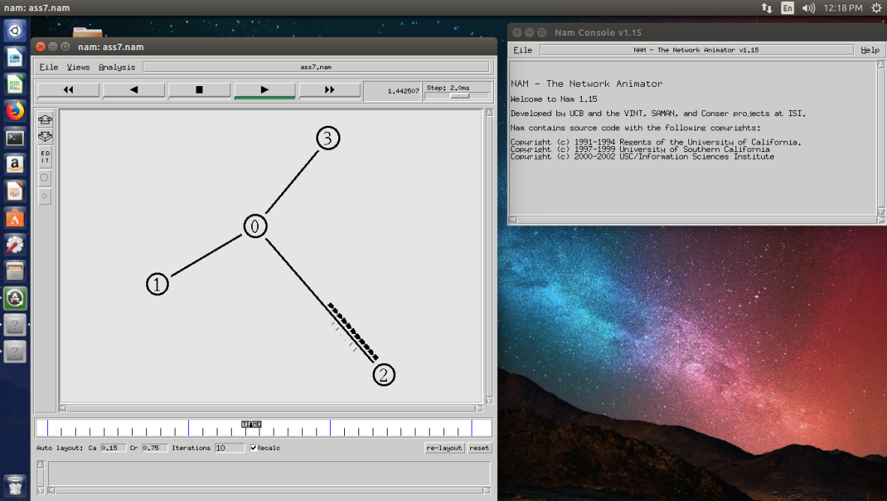

**Assignment-3 : FTP over TCP**

**Code:-**

set ns [new Simulator]

set nf [open ass7.nam w]

$ns namtrace-all $nf

set nt [open ass7.tr w]

$ns trace-all $nt

proc finish {} {

global ns nf nt

$ns flush-trace

close $nf

close $nt

exec nam ass7.nam &

exit 0

}

set n1 [$ns node]

set n2 [$ns node]

set n3 [$ns node]

set n4 [$ns node]

$ns duplex-link $n1 $n2 10Mb 5ms SFQ

$ns duplex-link $n1 $n3 20Mb 10ms SFQ

$ns duplex-link $n1 $n4 30Mb 15ms SFQ

#Setup a TCP agent

set tcp [new Agent/TCP]

$ns attach-agent $n1 $tcp

set sink [new Agent/TCPSink]

$ns attach-agent $n3 $sink

$ns connect $tcp $sink

$tcp set packetsize_ 1024

$tcp set random_ true

$tcp set rate_ 0.02Mb

#Setup a FTP application over TCP connection

set ftp [new Application/FTP]

$ftp attach-agent $tcp

$ftp set type_ FTP

$ns at 1.0 "$ftp start"

$ns at 3.0 "$ftp stop"

$ns at 5.0 "finish"

$ns run

**Output:-**





**Assignment-4 : Network Dynamics using UDP**

**Code:-**

set ns [new Simulator]

$ns rtproto DV

set nf [open out.nam w]

$ns namtrace-all $nf

proc finish {} {

global ns nf

$ns flush-trace

close $nf

exec namout.nam&

exit 0

}

for {set i 0} {$i< 7} {incri} {

set n($i) [$ns node]

}

for {set i 0} {$i< 7} {incri} {

$ns duplex-link $n($i) $n([expr ($i+1)%7]) 1Mb 10ms DropTail

}

set udp [new Agent/UDP] #Setup an UDP agent

$ns attach-agent $n(0) $udp

set null [new Agent/Null]

$ns attach-agent $n(3) $null

$ns connect $udp $null

set cbr [new Application/Traffic/CBR] #Setup a CBRapplication over UDP connection

$cbr attach-agent $udp

$cbr set packetSize_ 500

$cbr set interval_ 0.005

$ns at 0.5 "$cbr start"

$ns rtmodel-at 1.0 down $n(1) $n(2) #Network failure

$ns rtmodel-at 2.0 up $n(1) $n(2)

$ns at 4.5 "$cbr stop"

$ns at 5.0 "finish"

$ns run

**Output:-**

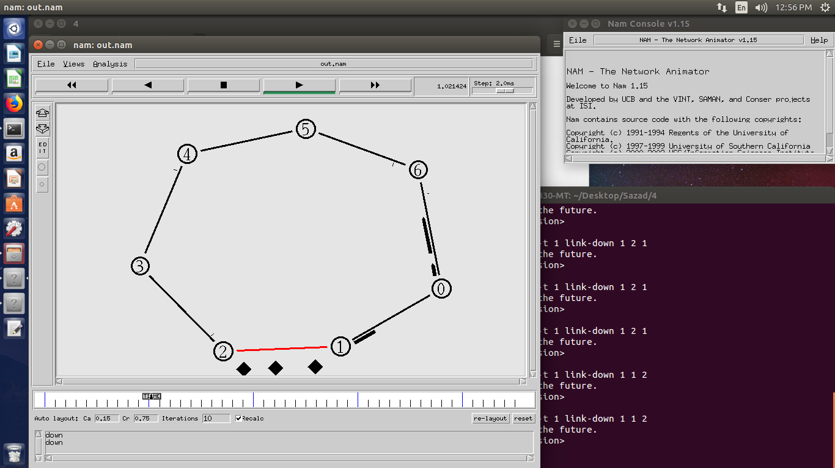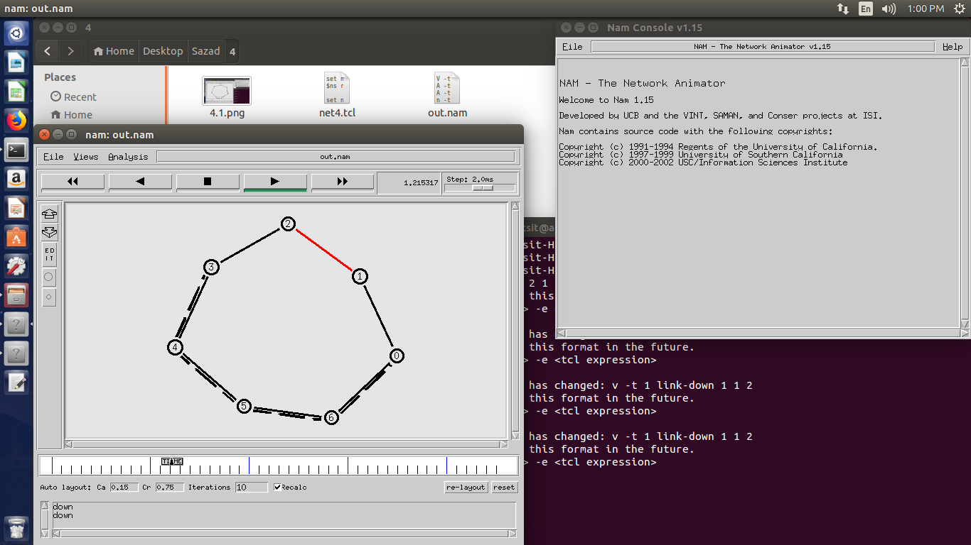

**Assignment-5 : Network Dynamics using TCP**

**Code:-**

set ns [new Simulator]

$ns rtproto DV

set nf [open proj1.nam w]

$ns namtrace-all $nf

proc finish {} {

global ns nf

$ns flush-trace

close $nf

exec nam proj1.nam &

exit 0

}

for {set i 0} {$i< 7} {incri} {

set n($i) [$ns node]

}

for {set i 0} {$i< 7} {incri} {

$ns duplex-link $n($i) $n([expr ($i+1)%7]) 1Mb 10ms DropTail

}

set tcp [new Agent/TCP] #Setup a TCP agent

$ns attach-agent $n(0) $tcp

set sink [new Agent/TCPSink]

$ns attach-agent $n(3) $sink

$ns connect $tcp $sink

$tcp set fid_ 1

$tcp set packetsize_ 512

$tcp set random_ true

$tcp set rate_ 0.02mb

set ftp [new Application/FTP] #Setup a FTP application over TCP connection

$ftp attach-agent $tcp

$ftp set type_ FTP

$ns at 0.5 "$ftp start"

$ns rtmodel-at 1.0 down $n(1) and $n(2) #Network Failure

$ns rtmodel-at 2.0 up $n(1) and $n(2)

$ns at 4.5 "$ftp stop"

$ns at 5.0 "finish"

$ns run

**Output:-**

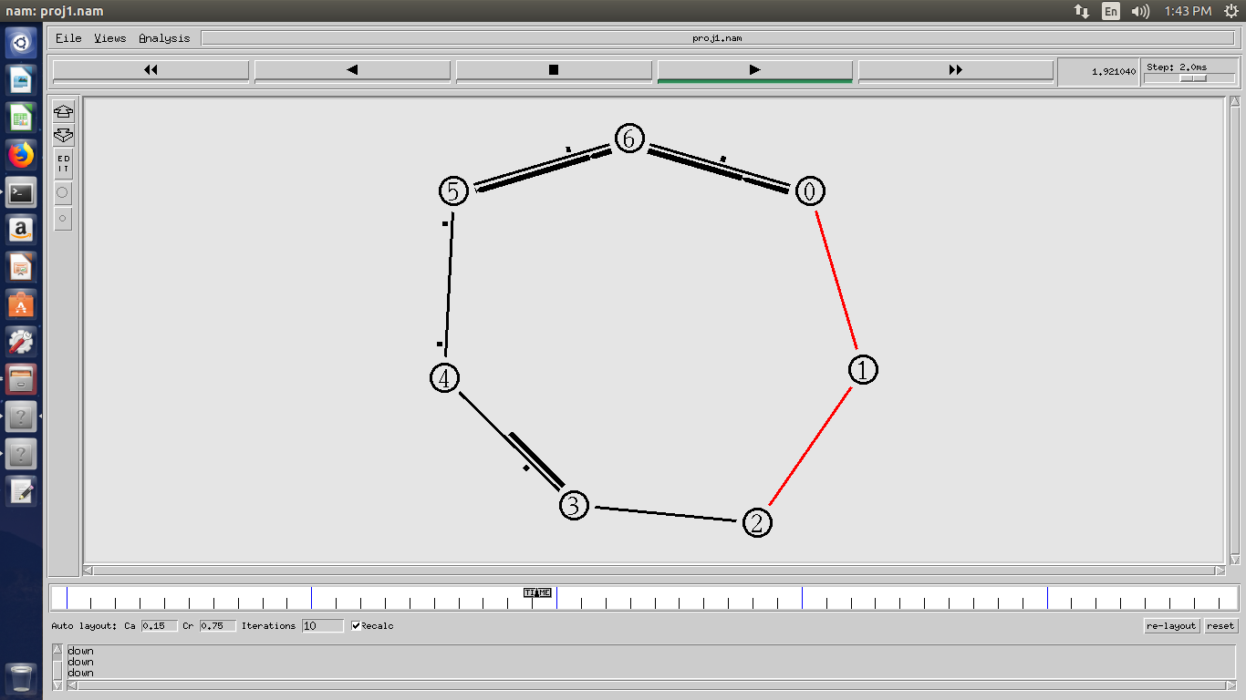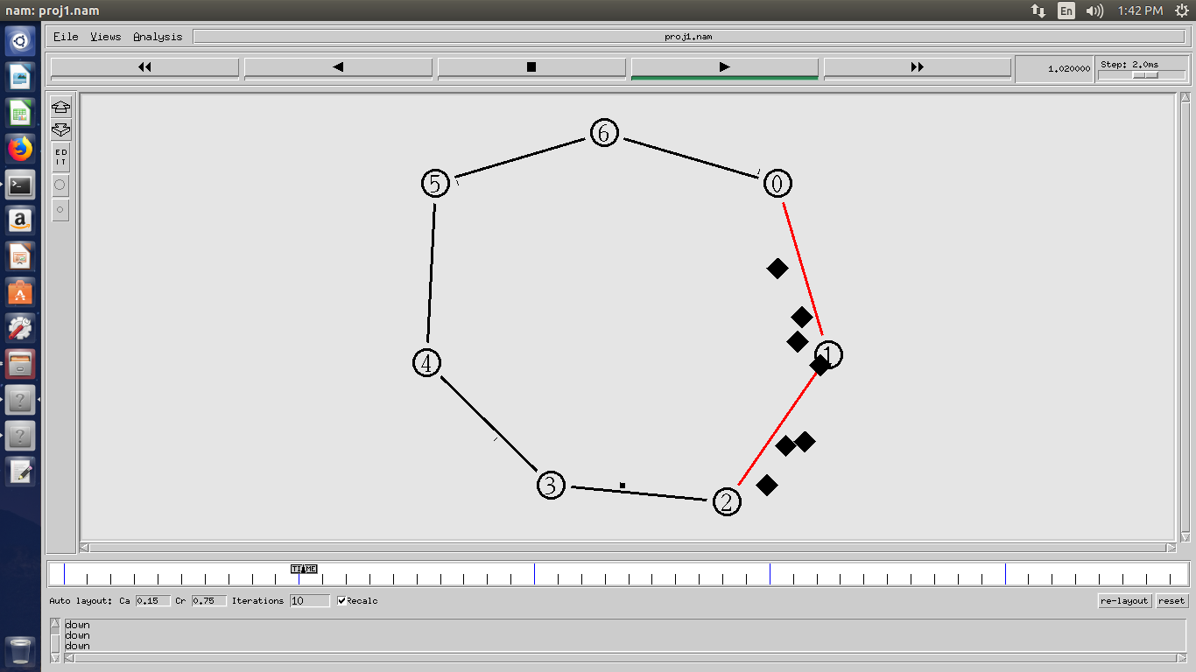

**Assignment-6 :TCP-FTP & UDP-CBR together with 2 different fid & Dynamic link failure**

**Code:-**

set ns [new Simulator]

set nf [open ass1.nam w]

set f [open ass1.tr w]

$ns namtrace-all $nf

$ns trace-all $f

$ns rtproto Session

proc finish {} {

global ns f

$ns flush-trace

close $f

exec nam ass1.nam &

exit 0

}

set n(1) [$ns node]

set n(2) [$ns node]

set n(3) [$ns node]

set n(4) [$ns node]

set n(5) [$ns node]

$ns duplex-link $n(1) $n(2) 20Mb 10ms DropTail

$ns duplex-link $n(1) $n(3) 20Mb 10ms DropTail

$ns duplex-link $n(2) $n(3) 20Mb 10ms DropTail

$ns duplex-link $n(3) $n(5) 10Mb 5ms DropTail

$ns duplex-link $n(4) $n(5) 10Mb 5ms DropTail

$ns duplex-link $n(2) $n(4) 10Mb 5ms DropTail

set tcp0 [new Agent/TCP]

$ns attach-agent $n(1) $tcp0

set sink [new Agent/TCPSink]

$ns attach-agent $n(5) $sink

$ns connect $tcp0 $sink

$tcp0 set fid_ 1

$tcp0 set packetsize_ 1024

$tcp0 set random_ true

$tcp0 set rate_ 0.02Mb

set ftp0 [new Application/FTP]

$ftp0 attach-agent $tcp0

$ftp0 set type_ FTP

set udp [new Agent/UDP]

$ns attach-agent $n(2) $udp

set null [new Agent/Null]

$ns attach-agent $n(5) $null

$ns connect $udp $null

$udp set fid_ 2

set cbr [new Application/Traffic/CBR]

$cbr attach-agent $udp

$cbr set packetsize_ 512

$cbr set rate_ 0.01Mb

$cbr set random_ false

$ns at 10.0 "$ftp0 start"

$ns at 0.0 "$cbr start"

$ns rtmodel-at 5.0 down $n(1) $n(3)

$ns rtmodel-at 8.0 up $n(1) $n(3)

$ns rtmodel-at 10.0 down $n(2) $n(3)

$ns rtmodel-at 18.0 up $n(2) $n(3)

$ns at 20.0 "$ftp0 stop"

$ns at 10.0 "$cbr stop"

$ns at 50.0 "finish"

$ns run

**Output** :-

